**Work Done Today**

**BY: Rishi Pandey**

Today I created a mlflow experiment for the first model and was in process of creating a mlflow experiment for 2nd model.

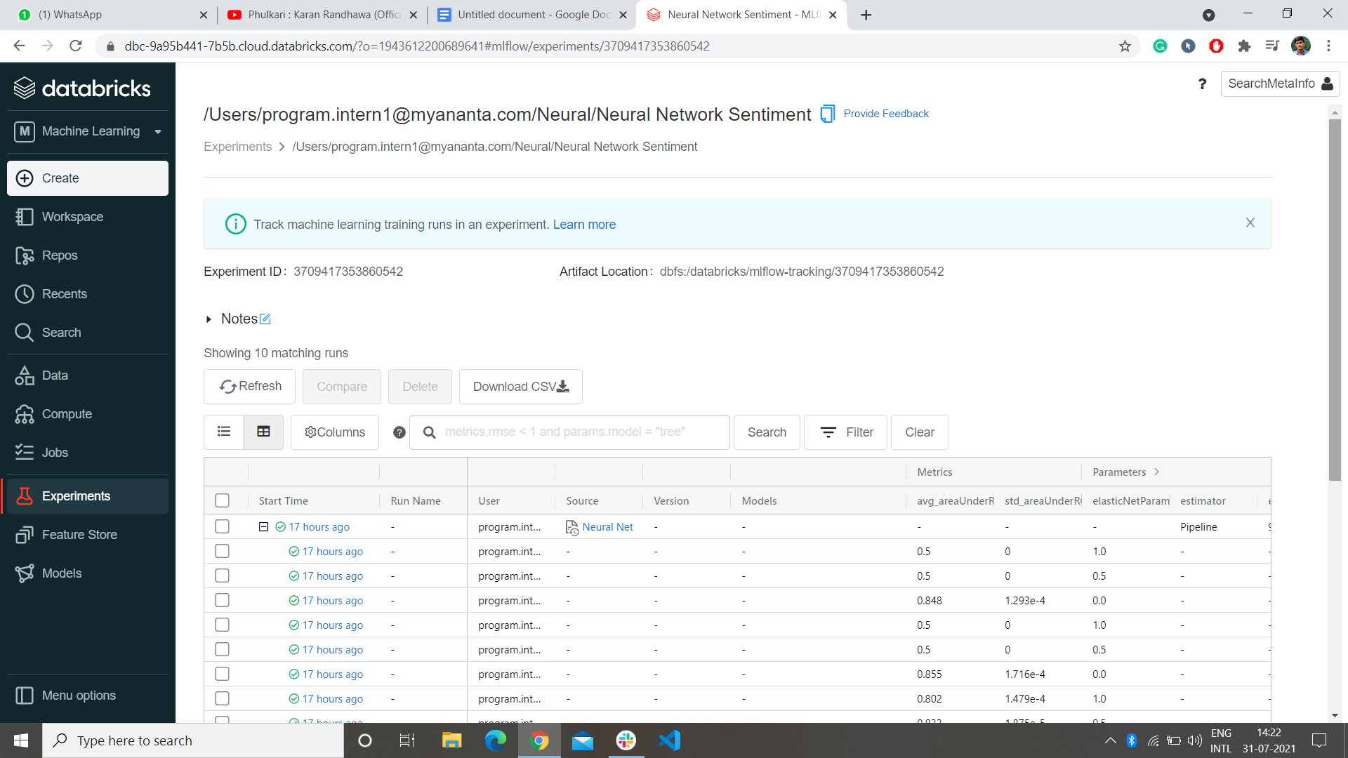

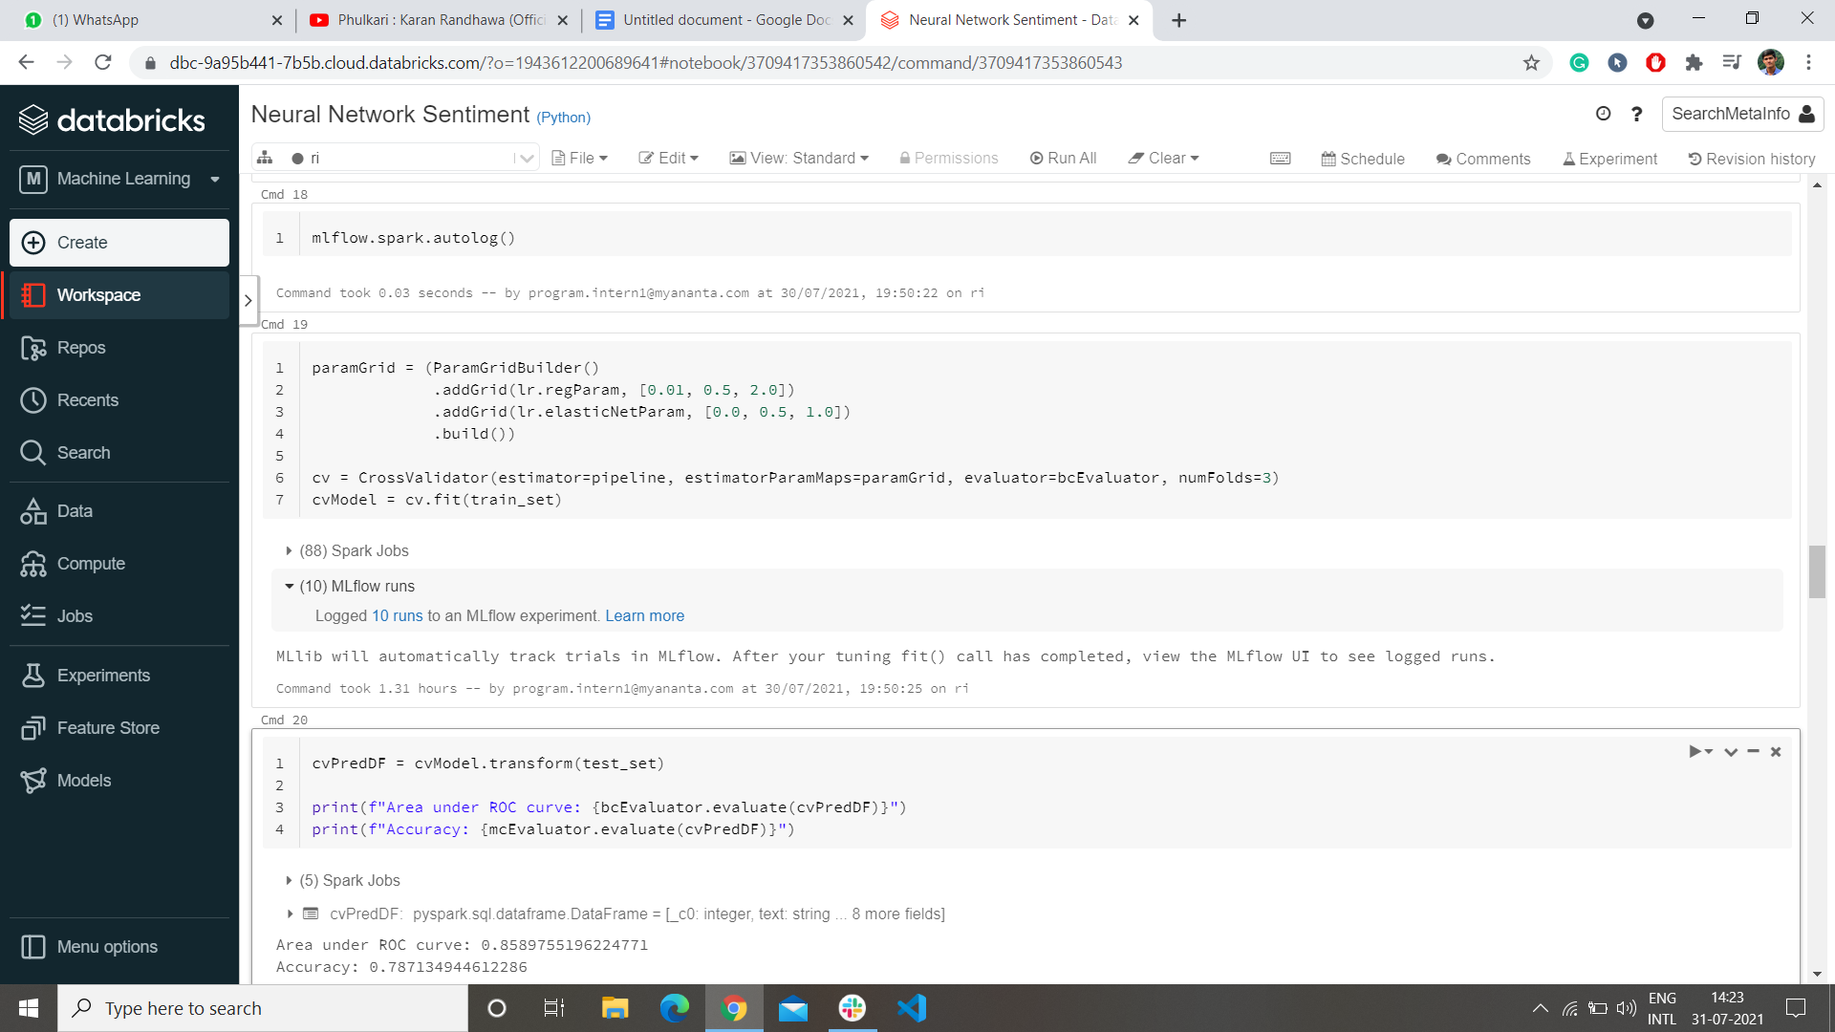

This cross-validation and logging it through the mlflow took 2 hours to run.